**Haputhanthiri R.S**

**IT24104341**

**PS lab – 08**

**01)**

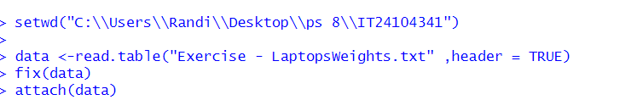

**02)**

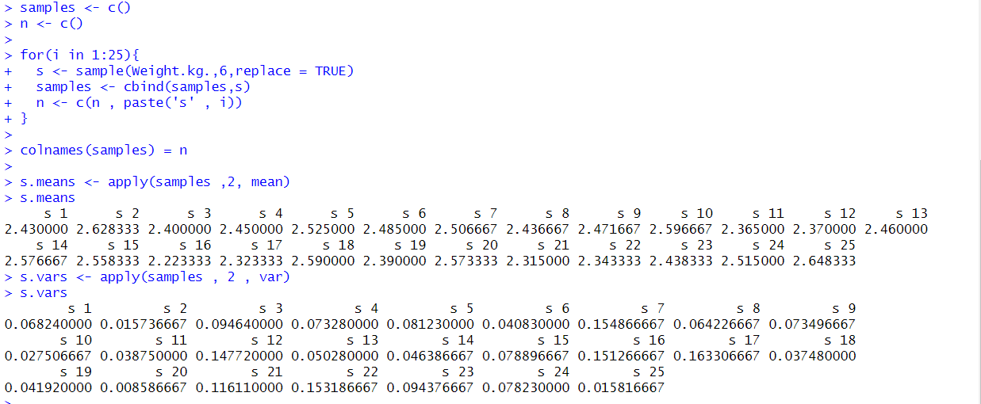

**03)**

